JAVA LAB 1

STUDENT NAME: PRISCILA NAMUSOKWE
STUDENT NUMBER: 202505751

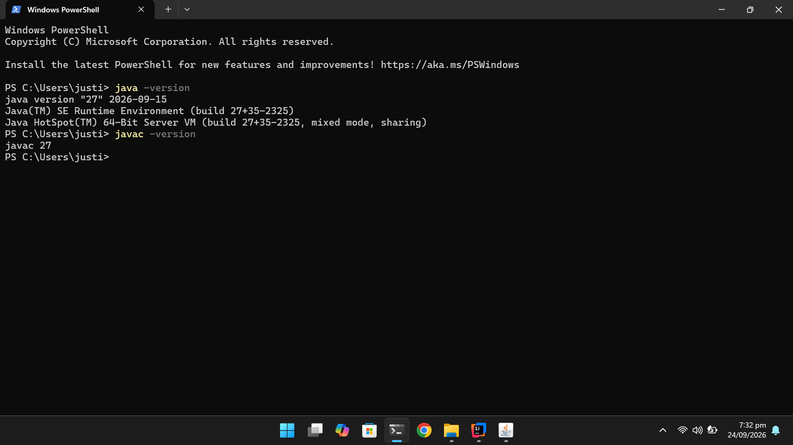
  - Java -version and javac -version

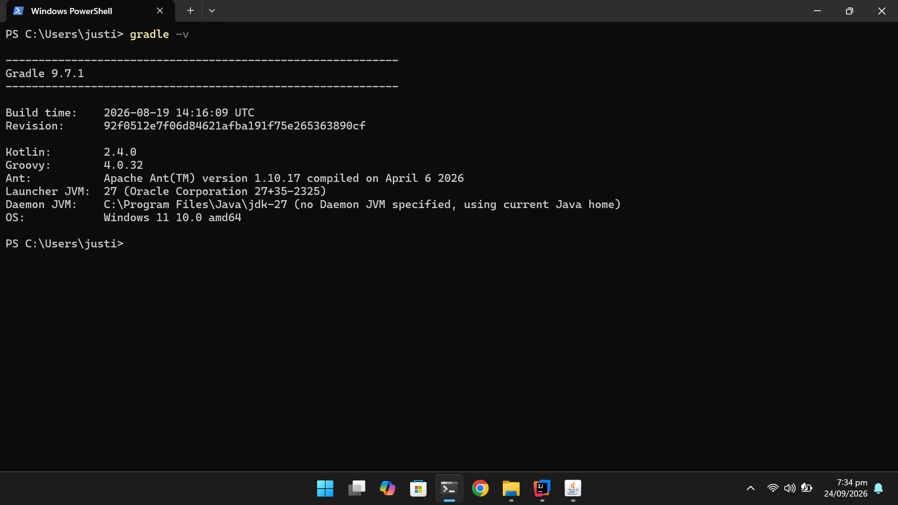
  - Gradle -v

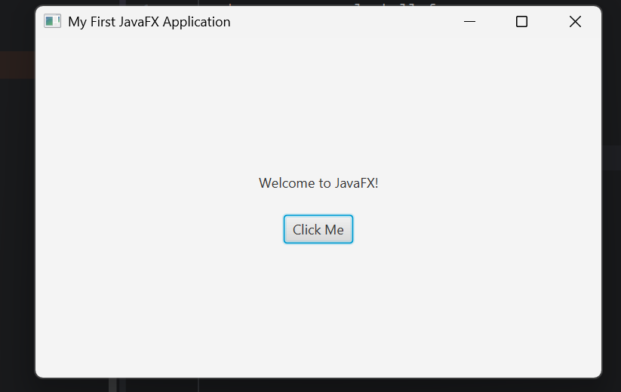
  - Before clicking

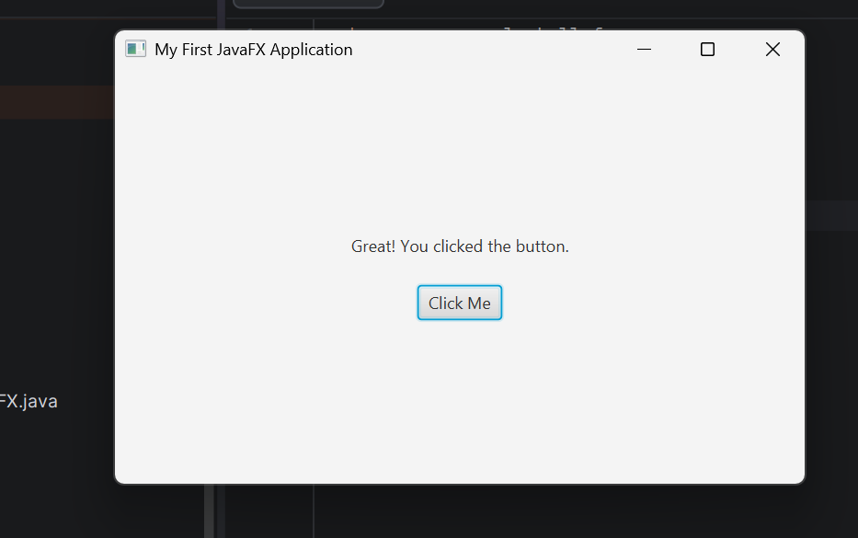
  - After clicking

